

Data Technician

Name: Edmilson Fernandes de Assuncao
Course Date: 1/12/2026
Table of contents
Day 1: Task 1 4
Day 2: Task 1 4
Day 2: Task 2 5
Day 4: Task 1 6
Day 4: Task 2 6
Day 4: Task 3 7
Course Notes 7
Python Additonal Resources 8
Exercise 1: You can either complete training on this website. 8
Exercise 2: Complete exercise on Google Colab and share your notebook with the trainer. 8
Exercise 3: Complete exercise on Google Colab and share your notebook with the trainer. 9
Exercise 4: Challenge yourself on hackerrank. Solve Python | HackerRank 9
Exercise 5: Practice on CodingChef. Print Coding Chef Question in Python 9
Exercise 6: Kaggle Data Visualization: Learn Data Visualization | Kaggle 9
Exercise 7: Kaggle Pandas Tutorial: Learn Pandas | Kaggle 10
Exercise 8: Video: Learn Pandas in Under 3 Hours | Filtering, Joins, Indexing, Data Cleaning, Visualizations - YouTube 10

Day 1: Task 1: Monday Morning
Please sign up on Cisco Academy website and complete learning.
- follow the link
Free Python Course by Cisco: No Prior Experience Necessary!
- Select get started with self-pace
- sing up using Just IT email
- This is free beginner python course.

How to Share your notebook
- Select share
- Enter and add trainers’ email yusufs@justit.co.uk
- Make sure that you set General access to Anyone with the link.
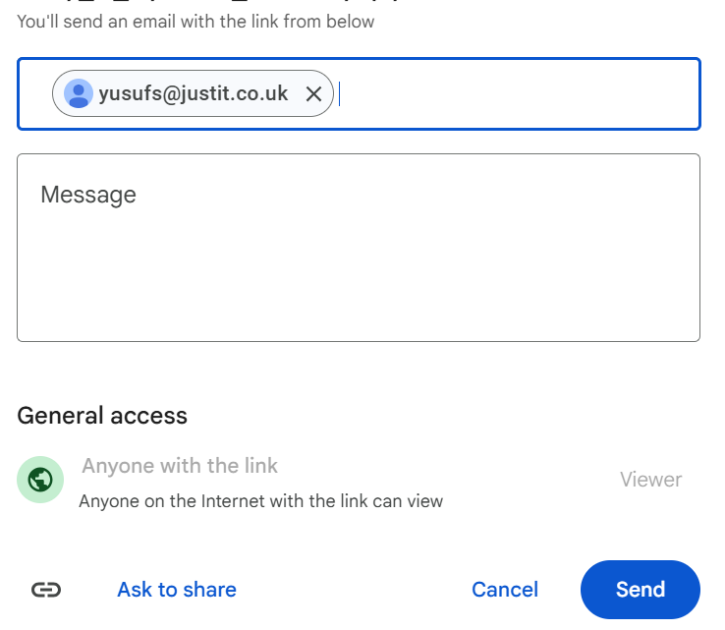
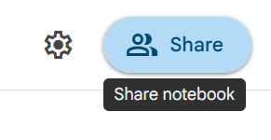
- Press send.

Day 1: Task 2
- Follow below link. https://colab.research.google.com/drive/1X2y7wcJ768lPnnq4HEOK2hpeefz3Bzl5?usp=sharing
- Save a copy of this notebook in your Drive and rename by adding your name to the end.
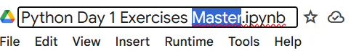

- Go through the notebook and complete the exercises at the end.
- Share your notebook with your trainer.

Day 2: Task 1
- Follow below link.
- https://colab.research.google.com/drive/1FMs6Dqg_tTSqn0wAuTa0aTX_vkYwkEJM?usp=sharing
- Save a copy of this notebook in your Drive and rename by adding your name to the end.
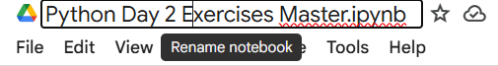

- Go through the notebook and complete the exercises at the end.
- Share your notebook with your trainer.

Day 2: Task 2

It is a common software development interview question to create the below with a certain programming language. Create the below using Python syntax, test it and past the completed syntax and output below.

FizzBuzz:

Go through the integers from 1 to 100.
If a number is divisible by 3, print "fizz."
If a number is divisible by 5, print "buzz."
If a number is both divisible by 3 and by 5, print "fizzbuzz."
Otherwise, print just the number.
Use loops and if statements.

Paste your completed work to the right | numbers = 1  while numbers <= 100:  if numbers % 3 == 0 and numbers % 5 == 0:  print("fizzbuzz")  numbers += 1  elif numbers % 3 == 0:  print("fizz")  elif numbers % 5 == 0:  print("buzz")  else:  print(numbers)  numbers += 1

Day 4: Task 1

- Follow below link. https://colab.research.google.com/drive/1ZLG3LgzHUgYfVlLzs8W2OpBugHWRBTKP?usp=sharing
- Save a copy of this notebook in your Drive and rename by adding your name to the end.

- Go through the notebook and complete the exercises at the end.
- Share your notebook with your trainer.

Day 4: Task 2
- Follow below link. https://colab.research.google.com/drive/1OIlNFt7vYRuikgRUw8HemN543jdeM8lM?usp=sharing
- Save a copy of this notebook in your Drive and rename by adding your name to the end.
- Download the dataset here. https://drive.google.com/file/d/14Yz-06ykP-KL-lKFFckqfJk2jVm59zY4/view?usp=sharing
- Go through the notebook and complete the exercises at the end.
- Share your notebook with your trainer.

Day 4: Task 3
- Follow below link. https://colab.research.google.com/drive/1SzWwpS86Eju3tp_EDpBKFmYqFseWVam_?usp=sharing
- Save a copy of this notebook in your Drive and rename by adding your name to the end.
- Download the dataset here. https://drive.google.com/file/d/1FSo51F-FDXoj7mQQoKY8tk6iFg2l6YiJ/view?usp=sharing
- Go through the notebook and complete the exercises at the end.
- Share your notebook with your trainer.

Course Notes

It is recommended to take notes from the course, use the space below to do so, or use the revision guide shared with the class:

Python Additonal Resources

Exercise 1: You can either complete training on this website.
Free Python Course by Cisco: No Prior Experience Necessary! (highly recommended, free course. Certification upon completion.)
Or complete other exercises.

Exercise 2: Complete exercise on Google Colab and share your notebook with the trainer.
- Write a Python program to print "Hello, World!"
print("Hello, World!")
- Write a Python program to calculate the sum of two numbers entered by the user.
num1 = int(input("Enter the first number: "))
num2 = int(input("Enter the second number: "))
sum1 = num1 + num2
print(f"The sum of {num1} and {num2} is {sum1}.")
- Write a Python program to convert temperature entered by user from Celsius to Fahrenheit.
celsius = float(input("Enter the temperature in Celsius: "))
fahrenheit = (celsius * 9/5) + 32
print(fahrenheit)
- Write a Python program to calculate the area of a rectangle given its length and width
length = float(input("Enter the length of the rectangle: "))
width = float(input("Enter the width of the rectangle: "))
area = length * width
print(f"The area of the rectangle with length {length} and width {width} is {area}.")
- Create a program that takes a user's name and age as input and prints a greeting message
name = input("Enter your name: ")
age = int(input("Enter your age: "))
print(f"Hello, {name}! ")
print("Nice to meet you.")
print(f"You are {age} years old.")
- Write a program to check if a number is even or odd
number = int(input("Enter a number: "))
if number % 2 == 0:
print(f"{number} is an even number.")
else:
print(f"{number} is an odd number.")

- Given a list of numbers, find the maximum and minimum values
numbers = [10, 5, 20, 15, 30]
maximum = max(numbers)
minimum = min(numbers)
- Create a Python function to check if a given string is a palindrome
word = input("Enter a word: ")
if word == word[::-1]:
print(f"{word} is a palindrome.")
else:
print(f"{word} is not a palindrome.")

- Calculate the compound interest for a given principal amount, interest rate, and time period
principal = float(input("Enter the principal amount: "))
interest_rate = float(input("Enter the interest rate: "))
time_period = int(input("Enter the time period: "))
compound_interest = principal * (1 + interest_rate/100)**time_period
print(f"The compound interest for a principal amount of {principal}, an interest rate of {interest_rate}%, and a time period of {time_period} years is {compound_interest}.")

- Write a program that converts a given number of days into years, weeks, and days
number_of_days = int(input("Enter the number of days: "))
year = number_of_days // 365
week = (number_of_days % 365) // 7
day = (number_of_days % 365) % 7
print (f"{number_of_days} days is {year} years {week} weeks and {day} days")

- Given a list of integers, find the sum of all positive numbers
num1 = [23, -34, 20, -45, -1, 50, 15]
num_positive = [num for num in num1 if num > 0]
sum_positive = __builtins__.sum(num_positive)
print(f"The sum of positive numbers is: {sum_positive}")

- Create a program that takes a sentence as input and counts the number of words in it
sentence = input("Enter a sentence: ")
words = sentence.split()
number_of_words = len(words)
print(f"The number of words in the sentence is: {number_of_words}")

- Write a program to check if a number is prime.
n = int(input("Enter a number: "))
if n < 2:
print(f"{n} is not a prime number.")
else:
n >= 2
for i in range(2, n):
if n % i == 0:
print(f"{n} is not a prime number.")
break
else:
print(f"{n} is a prime number")

- Write a program that checks if a given number is positive, negative, or zero.
num = int(input("Enter a number: "))
if num > 0:
print("The number is positive.")
elif num < 0:
print("The number is negative.")
else:
print("The number is zero.")

- Create a loop that prints the first 10 even numbers.
for i in range(2, 21, 2):
print(i)

- Implement a program that finds the largest number in a list.
numbers = [1, 2, 3, 4, 5, 6, 7, 8, 9, 10]
largest_number = numbers[0]

- Create a program that takes a year as input and checks if it is a leap year or Not
year = int(input("Enter a year: "))
if (year % 4 == 0 and year % 100 != 0) or (year % 400 == 0):
print(f"{year} is a leap year.")
else:
print(f"{year} is not a leap year.")

- Calculate the sum of digits of a given number.
num = input("Enter a number: ")
sum = 0
for digit in num:
sum += int(digit)
print(sum)

- Create a program that checks if a given string is a palindrome.
string = input("Enter a string: ")
if string == string[::-1]:
print("The string is a palindrome.")
else:
print("The string is not a palindrome.")

Exercise 3: Complete exercise on Google Colab and share your notebook with the trainer.

You are going to use the different Python concepts seen to build a program that will simulate the behaviour of an ATM. Follow the instructions below:

Print a main menu to ask the user different options for displaying the bank account balance, for depositing money, to withdraw money, and to exit from the ATM. Ideally create a function for each menu option to be executed. Use conditional statements for asking the user the different menu options.
Additional (optional): Ask the user a PIN to access to the ATM menu once the PIN is correct otherwise ask the user to try again.
Prompt the user to enter an option:
  - If ‘1’ is entered, display the current balance and return to main menu.
  - If ‘2’ is entered, print a sub-menu with different withdrawal amounts (give also a choice for “other amount’ to let the user enter an amount) :
  - Check that the requested withdrawal is allowed, print a message to show that the money has been withdrawn, calculate the new balance and return to main menu.
  - If ‘other_amount’ is selected, then prompt the user for an integer value. Check this number is a multiple of 10 and that the withdrawal is permitted, print a message to show that the money has been withdrawn, calculate the new balance and return to main menu.
- If ‘exit’ is selected print a goodbye message and exit (break).
- If another value is entered, print an error message and print the menu again.

-Re-use the ATM menu options across the program to ask the user if he/she would like to perform another operation on the bank account.

pin1=1234
pin2=0
bal=float(3692.36)
pin2 = int(input("Enter your four digit pin: "))
while pin2 != pin1:
print("Pin Invalid! Try again")
pin2 = int(input("Enter your four digit pin: "))
print("1-Account Balance \n2-Depositing Money \n3-Withdraw Money \n4-Exit")
m_menu = int(input("Enter the number corresponding to the desired option:\n"))
while m_menu == 0 or m_menu >= 6:
print("Invalid opption.")
m_menu = int(input("Enter the number corresponding to the desired option:\n"))
if m_menu == 1:
print(f"Your current Balance is £{bal}")
print("Thank you for unising our services")
elif m_menu == 2:
bal1 = float(input("Enter the amount you would like to deposit. \n£:"))
bal += bal1
print(f"Your current Balance is £{bal}")
print("Thank you for unising our services")
elif m_menu == 3:
bal1 = float(input("Enter the amount you would like to withdraw. \n£:"))
bal -= bal1
print(f"Your current Balance is £{bal}")
print("Thank you for unising our services")
else:
print("Thank you for unising our services")

Exercise 4: Challenge yourself on hackerrank. Solve Python | HackerRank

Exercise 5: Practice on CodingChef. Print Coding Chef Question in Python

Exercise 6: Kaggle Data Visualization: Learn Data Visualization | Kaggle

Exercise 7: Kaggle Pandas Tutorial: Learn Pandas | Kaggle

Exercise 8: Video: Learn Pandas in Under 3 Hours | Filtering, Joins, Indexing, Data Cleaning, Visualizations - YouTube

We have included a range of additional links to further resources and information that you may find useful, these can be found within your revision guide.

END OF WORKBOOK

Please check through your work thoroughly before submitting and update the table of contents if required.

Please send your completed work booklet to your trainer.

